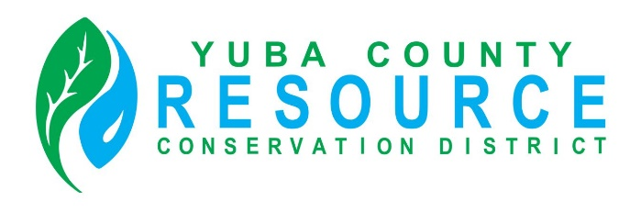

Regular Meeting of the Board of Director’s
Friday, September 12, 2025
9:30 A.M.
Yuba County Agricultural Commissioner’s Office conference room
915 8th Street, Suite 127, Marysville, California

Conference Room Directions and Participation Options

This meeting will be held in person at the Yuba County Agricultural Commissioner’s Office conference room. To reach the Agricultural Commissioner’s Office, enter the main entrance of the Yuba County Office Building, and either follow the directions provided on the signage or ask the officers at the main entrance for directions.

The public is invited to listen, observe and, at designated times, provide comments during the meeting.

AGENDA

ROLL CALL

CHANGES TO AGENDA
The Board may make any necessary additions, deletions, or corrections to the agenda. This includes requesting that an item be removed from Consent or moved to another part of the agenda for discussion and separate Board action.

PUBLIC COMMENT
Opportunity for public comment on any NON-AGENDIZED items within the jurisdiction of the RCD Board. However, no action may be taken by the Board on topics of matters presented during this PUBLIC INPUT agenda item. (THE PUBLIC MUST ADDRESS THE BOARD ON SPECIFIC AGENDIZED ITEMS ONLY DURING THE BOARD’S CONSIDERATION OF THE ITEM.)

CONSENT ITEMS
The Board may approve Consent Items with a single vote. At the appropriate time as called by the Board President, members of the public may make a comment on Consent Items prior to Board action.
- Approval of the minutes of the August 08, 2025, Regular Board Meeting (either as written or as corrected).

DISCUSSION AND ACTION ITEMS
- Director Lindman Medical Leave of Absence
- Discussion and Appointment of Board Member Roles and Responsibilities including interim Signature Authority.
- Update on financial status
- Update on Yuba Water Agency Funding
- Review of NRCS Local Working Group Meeting
- Discuss and approve Yuba County RCD Receiving $24,000 loan from CARCD to pay Forest Management Plan Contractor. (0% rate, repayment by 12-31-2025)
- Outreach (Director Sharp)
- Executive Director Report (See written report)
- Upcoming Events

BOARD PRESIDENT’S REPORT

DIRECTORS’ COMMENTS AND REPORTS
- Comments and Reports
- Agenda Items for Next Board Meeting

ADJOURNMENT

