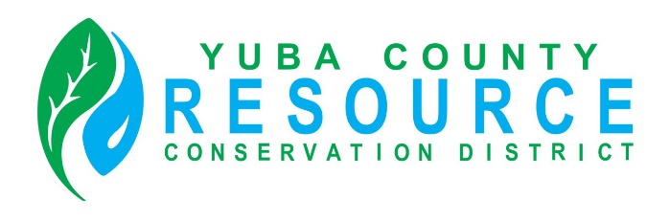

Regular Meeting of the Board of Director’s
Friday, December 12, 2025
9:30 A.M.
Yuba County Agricultural Commissioner’s Office conference room
915 8th Street, Suite 127, Marysville, California

Conference Room Directions and Participation Options

This meeting will be held in person at the Yuba County Agricultural Commissioner’s Office conference room. To reach the Agricultural Commissioner’s Office, enter the main entrance of the Yuba County Office Building, and either follow the directions provided on the signage or ask the officers at the main entrance for directions.

The public is invited to listen, observe and, at designated times, provide comments during the meeting.

For members of the public interested in viewing and having the ability to comment at the public meeting via Zoom Video Conference and Audio Teleconference, an internet enabled computer equipped with a microphone and speaker or a mobile device with a data plan is required. Use of webcam is optional. Login information is provided below.

Join Zoom Meeting
Zoom Meeting Link
Meeting ID: 401 531 1466

One tap mobile
+16694449171,,5127564528# US
+13462487799,,5127564528# US (Houston)
Phone
1 669 444 9171 US
Meeting ID: 512 756 4528

Find your local number

AGENDA

ROLL CALL

CHANGES TO AGENDA
The Board may make any necessary additions, deletions, or corrections to the agenda. This includes requesting that an item be removed from Consent or moved to another part of the agenda for discussion and separate Board action.

PUBLIC COMMENT
Opportunity for public comment on any NON-AGENDIZED items within the jurisdiction of the RCD Board. However, no action may be taken by the Board on topics of matters presented during this PUBLIC INPUT agenda item. (THE PUBLIC MUST ADDRESS THE BOARD ON SPECIFIC AGENDIZED ITEMS ONLY DURING THE BOARD’S CONSIDERATION OF THE ITEM.)

CONSENT ITEMS
The Board may approve Consent Items with a single vote. At the appropriate time as called by the Board President, members of the public may make a comment on Consent Items prior to Board action.
- Approval of the minutes of the November 14, 2025, Regular Board Meeting (either as written or as corrected).

DISCUSSION AND ACTION ITEMS
- Financial Report
- Audit update
- Banking resolution update
- Review bids and choose contractor for the Camptonville Project ( Yuba Foothills Hazard Fuel Reduction) funded by Cal Fire Wildfire Prevention Grant.
- Review and approve Zoom subscription renewal ($184.80)
- Approve of Snellings Bookkeeping invoice payment for the total of ($800.00)
- Approve payment of invoice from CWDI in the amount of ($8,945.00) for grant writing support
- Review and approve ED staff time for April, May, June, July and possibly August ($5612.32, $5612.32, $5612.32, $5612.32, $9067.69) totaling $31,516.97
- Review and approve Foresters Co-Op invoice in the amount of $4,825.00 for flagging, project layout and mapping.
- Discussion and possible approval of CARCD Membership dues payment
- Discussion of Contract Bookkeeper position

- Executive Director Report
  - CARCD Wildfire Resilience Forestry block grant update (Oregon House)
  - CalFire Wildfire Prevention Grant update (Camptonville)
  - Project updates
  - Other
- Upcoming Events
- Team building exercises.

BOARD PRESIDENT’S REPORT

DIRECTORS’ COMMENTS AND REPORTS
- Comments and Reports
- Agenda Items for Next Board Meeting

ADJOURNMENT

