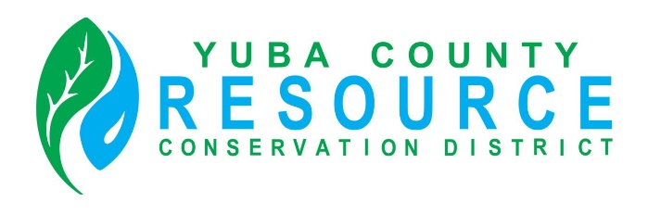

Regular Meeting of the Board of Director’s
Friday, June 19th, 2026
9:30 A.M.
Yuba County Agricultural Commissioner’s Office conference room
915 8th Street, Suite 127, Marysville, California

Conference Room Directions and Participation Options

This meeting will be held in person at the Yuba County Agricultural Commissioner’s Office conference room. To reach the Agricultural Commissioner’s Office, enter the main entrance of the Yuba County Office Building, and either follow the directions provided on the signage or ask the officers at the main entrance for directions.

The public is invited to listen, observe and, at designated times, provide comments during the meeting.

For members of the public interested in viewing and having the ability to comment at the public meeting via Zoom Video Conference and Audio Teleconference, an internet enabled computer equipped with a microphone and speaker or a mobile device with a data plan is required. Use of webcam is optional. Login information is provided below.

Join Zoom Meeting
Zoom Meeting Link
Meeting ID: 401 531 1466

One tap mobile
+16694449171,,5127564528# US
+13462487799,,5127564528# US (Houston)
Phone
1 669 444 9171 US
Meeting ID: 512 756 4528

Find your local number

AGENDA

ROLL CALL

CHANGES TO AGENDA
The Board may make any necessary additions, deletions, or corrections to the agenda. This includes requesting that an item be removed from Consent or moved to another part of the agenda for discussion and separate Board action.

PUBLIC COMMENT
Opportunity for public comment on any NON-AGENDIZED items within the jurisdiction of the RCD Board. However, no action may be taken by the Board on topics of matters presented during this PUBLIC INPUT agenda item. (THE PUBLIC MUST ADDRESS THE BOARD ON SPECIFIC AGENDIZED ITEMS ONLY DURING THE BOARD’S CONSIDERATION OF THE ITEM.)

CONSENT ITEMS
The Board may approve Consent Items with a single vote. At the appropriate time as called by the Board President, members of the public may make a comment on Consent Items prior to Board action.
- Approval of the minutes of the May 08, 2026, Regular Board Meeting (either as written or as corrected).

DISCUSSION AND ACTION ITEMS
- Overview of Financial position
- Approval of invoice from Adema Environmental for avian survey costs related to the Camptonville Project. ($6,650.00)
- Approval of invoice from Upper Valley Industries for work done with Cal Recycle Cycle 85. ($90,127.55)
- Approval of payment of March 2026 invoice from CARCD for Executive Directors staff time. ($6,045.12)
- Consideration, discussion and vote of “Standing Dead” film event sponsorship in partnership with the Yuba Foothills Fire Safe Coalition.
- Update on Annual Audit and draft documents.

Executive Directors Report
See written report provided

BOARD PRESIDENT’S REPORT

DIRECTORS’ COMMENTS AND REPORTS
- Comments and Reports
- Agenda Items for Next Board Meeting

ADJOURNMENT

